SE TERM PROJECT
Software Requirements Specification

Quran App



Project Advisor

Mr. Sawail Khan

Presented by:
Group ID: 05

Student Reg# Student Name

Faculty of Computer Science and Information Technology

The Superior University

Software Requirements Specification

Version <Version # 1.0>

Quran App

Advisor: Mr. Sawail Khan

Group ID: 05

Member Name | Primary Responsibility | % Contribution | Roll No | Serial # | Sign
Muhammad Ahmad Naveed | Project Lead / System Architect | 60 | 149
Muhammad Saqib Imran | Co-Leader / Interaction Designer & Requirement Analyst | 25 | 109
Muhammad Fahad | Research & Testing | 15 | 144

Table of Contents
List of Figures v
List of Tables vi
Revision History vii
1. Introduction and Background 8
1.1 Product (Problem Statement) 8
1.2 Background 8
1.3 Scope 9
1.4 Objective(s)/Aim(s)/Target(s) 9
1.5 Challenges 10
1.6 Learning Outcomes 11
1.7 Nature of End Product 11
1.8 Completeness Criteria 12
1.9 Business Goals 13
1.10 Related Work/ Literature Survey/ Literature Review 13
1.11 Document Conventions 14
2. Overall Description 15
2.1 Product Features 15
2.2 User Classes and Characteristics 16
2.3 Operating Environment 17
2.4 Design and Implementation Constraints 18
2.5 Assumptions and Dependencies 19
3. Project Management. 20
3.1 Work Breakdown Structure (WBS). 20
3.2 Create Milestone table 22
3.3 Develop an Activity Graph. 23
3.4 Find the Critical Path. 24
3.4.1 Activity List and Durations 24
3.4.2 Forward Pass Calculation 24
3.4.3 Backward Pass Calculation 25
3.4.4 Calculate Slack and Determine Critical Path 26
3.4.5 Conclusion 27
3.5 Create a Gantt chart. 27
~~~~~~~~~~ Phase II ~~~~~~~~~~ 29
4. Functional Requirements 29
4.1 Use Case Diagram 29
4.1.1 View Welcome Screen and Navigate 30
4.1.2 Surah Module 31
4.1.3 Juz Module 32
4.1.4 Namaz Timing Module 33
4.1.5 Direction / Qibla Module 34
4.1.6 Tasbee / Counter Module 35
Requirements Analysis and Modeling 36
5 Nonfunctional Requirements* 38
5.1 Performance Requirements 38
5.2 Safety Requirements 40
5.3 Security Requirements 41
5.4 Additional Software Quality Attributes 42
6 Other Requirements 43
7 Designing 46
7.1 Complete class diagram 46
7.2 Complete Data Flow Diagram (DFD) 47
7.3 Complete ER Diagram 48
7.4 Physical design of your database 50
7.5 Information on use of design patterns while designing the modules 50
7.6 Make a Sequence and a Collaboration diagram of following. 52
7.6.5 Scenario 1 52
7.6.6 Scenario 2 54
8 Estimation 57
8.1 Cost-Benefit Estimation 57
8.1.1 Cost Estimation 57
8.1.2 Benefit Estimation 58
8.1.3 Return of Investment (ROI) {1st year} 58
8.1.4 %gain on ROI {1st year} 58
8.1.5 Payback Period in years 59
8.2 FP based Estimation 59
8.3 COCOMO Estimation 60
9. References 61
10. Appendix A: Glossary 63

\

List of Figures
Figure 1 20
Figure 2 22
Figure 3 22
Figure 4 27
Figure 5 29
Figure 6 36
Figure 7 45
Figure 8 46
Figure 9 46
Figure 10 47
Figure 11 48
Figure 12 51
Figure 13 53
Figure 14 53
Figure 15 55
Figure 16 55

List of Tables
Table 1 21
Table 2 23
Table 3 24
Table 4 25
Table 5 26
Table 6 30
Table 7 31
Table 8 32
Table 9 33
Table 10 34
Table 11 35
Table 12 37
Table 13 37
Table 14 37
Table 15 37
Table 16 56
Table 17 57
Table 18 58

Revision History
Name | Date | Reason For Changes | Version

Introduction and Background
The Quran App is an Android-based mobile application designed to help Muslims access the Holy Quran, Qibla Direction, and Namaz Timings from one integrated platform.
The idea comes from the growing demand for a lightweight, hybrid (online/offline) Islamic application that provides core utilities for daily worship. The motivation is to make access to the Quran and essential prayer tools, especially for users with limited device storage or inconsistent internet connectivity. The Quran App aims to be the single most convenient digital resource for a Muslim's daily religious practice.
.

Product (Problem Statement)
The Quran App is an Islamic mobile application that enables users to read Quranic Surahs and Juz (with Urdu translation), listen to Arabic recitation, find Qibla Direction, and check Namaz Timings for any city. It solves the common problem of requiring multiple, resource-heavy applications by combining these essential Islamic utilities into a single, efficient, and user-friendly interface.

Background
The project belongs to the field of Islamic education and technology. Today, many people use mobile phones for religious learning and worship, but most Islamic apps are either too large need constant internet or don’t combine all important features in one place.
The Quran App created using MIT App Inventor solves these issues. It is designed to be lightweight and hybrid experience allowing users to read the Quran offline, listen to recitation online find the accurate Qibla Direction and check Namaz Timings for any city. The Quran text is saved as local HTML files so users can read it without internet, while Cloudinary is used to stream the audio

recitation smoothly whenever the user is online.

Scope
The Quran App is designed to serve as an all-in-one digital Islamic companion, enabling users to conveniently access essential religious resources in one place. The application focuses on simplicity,
accessibility and functionality, ensuring that users can engage with the Holy Quran and core daily
worship tools both online and offline. It aims to provide a seamless experience that integrates reading, listening and prayer related utilities for Muslims worldwide.
• A complete Surah and Juz index with efficient search and navigation.
• High quality Arabic audio recitation streamed through Cloudinary.
• Offline access to Quranic text along with its Urdu translation.
• Real-time Namaz timings fetched via an external API based on user-selected city.
• Accurate Qibla direction detection using device sensors and location data.
• A built-in Tasbeeh counter to support daily remembrance.
The scope specifically excludes advanced Tafseer detailed audio translations, and support for non-Android operating systems in this initial release.

Objective(s)/Aim(s)/Target(s)
The main objective of this project is to develop a comprehensive and efficient Islamic mobile application that consolidates essential daily worship tools into a single platform. The Quran App emphasizes usability, accessibility, and performance to ensure a meaningful and convenient user experience.
• Provide an accessible, lightweight, and user-friendly Quranic platform for Android users.
• Integrate Surah and Juz access, Qibla Direction, and Prayer Timings within one cohesive application.
• Enable seamless online audio streaming via Cloudinary without increasing the app size.
• Ensure complete offline access to the Quranic text through embedded HTML files.
• Offer accurate Qibla direction using an integrated system of device sensors and GPS functionality.
These objectives collectively aim to deliver a unified, reliable, and spiritually enriching experience for users.

Challenges
The development of the Quran App involves several technical and design challenges that must be addressed to ensure reliable performance and user satisfaction. These challenges include
• API Stability: Ensuring reliable integration and consistent performance of live API calls for prayer timings while handling potential network failures and response errors.
• Sensor Accuracy: Maintaining precise Qibla direction detection across different Android devices with varying compass and GPS sensor capabilities.
• Performance: Achieving smooth and uninterrupted audio streaming from Cloudinary under fluctuating network conditions.
• Resource Management: Minimizing the overall application size and optimizing efficiency within the constraints of the MIT App Inventor development environment.
• UI/UX Design: Creating a clean and accessible interface suitable for users of all age groups and levels of technical expertise.
Addressing these challenges is essential to fulfilling the app objectives of accessibility, reliability, and a seamless user experience.

Learning Outcomes
The development of the Quran App contributes to both technical and conceptual learning, strengthening practical skills in mobile application development. Through this project, the following outcomes are achieved:
• Proficient use of MIT App Inventor: Gaining hands-on experience with advanced components, logic structures, and project optimization within the MIT App Inventor environment.
• Location and sensor integration: Implementing and managing GPS and compass-based functionalities for accurate Qibla detection.
• API utilization: Acquiring practical expertise in retrieving and integrating live data through external APIs for features such as prayer timings.
• Cloud-based media management: Learning how to host, manage, and stream audio content efficiently using Cloudinary.
• Hybrid app design: Developing the ability to create and manage hybrid mobile applications that function seamlessly both online and offline.
These learning outcomes collectively strengthen the developer’s ability to design efficient, and scalable mobile applications.

Nature of End Product
The end product of this project will be a fully functional, installable Android application (.apk). It will feature a modular design composed of distinct main screens, each serving a specific purpose to enhance user experience and accessibility.
The primary modules include:
• Surah Screen: Displays a list of all Surahs with options for reading and listening to recitations.
• Juz Screen: Provides structured navigation for all thirty parts (Juz) of the Holy Quran.
• Namaz Timings Screen: Allows users to input a city name and view accurate, API-based prayer times.
• Qibla Direction Screen: Utilizes the device’s compass and location sensors to indicate the correct Qibla direction.
• Tasbeeh Counter Screen: Offers a simple digital counter for recording dhikr (remembrance).
The application will operate offline for Quran reading and require an internet connection for audio recitation streaming and prayer timing retrieval.

Completeness Criteria
The Quran App project will be considered complete and ready for final evaluation upon successfully meeting all functional and quality requirements, which include:
- Content & Access: All 30 Juz and 114 Surahs must be fully accessible and readable in offline mode.
- Audio Functionality: Audio recitations for all Surahs must stream successfully via the Cloudinary service.
- Namaz Timings: The API must provide accurate and reliable prayer times for a wide range of global cities.
- Qibla Direction: The feature must function accurately and consistently across standard Android devices using compass and GPS sensors.
- Tasbeeh Counter: The counter must operate correctly, supporting increment and reset actions.

- Quality Assurance: The application must pass final QA and UAT without any major functional errors or crashes.
Meeting these criteria confirms the app is fully functional, user-ready, and aligned with its objectives.

Business Goals
The Quran App is developed not only as a functional mobile application but also to achieve several broader business and strategic objectives:
• Community Service: Provide a free, accessible Islamic utility app for the global Muslim community, fostering goodwill, trust, and social impact.
• Digital Leadership: Establish a reliable, lightweight digital platform that serves as a trusted source for daily worship and Quranic learning.
• Platform Foundation: Create a stable, modular framework to support future feature expansion, such as an Islamic calendar, collections of Duas, and additional educational content.
• User Retention: Encourage long-term user engagement by delivering fast, stable, and dependable performance, particularly through the app’s hybrid online/offline functionality.

Related Work/ Literature Survey/ Literature Review
Several established Islamic mobile applications such as Quran Majeed, iQuran, and Al-Quran offer comprehensive features for Quranic reading and recitation. However, these applications are often associated with large installation sizes (primarily due to embedded audio) and typically require constant internet connectivity, which can limit usability for users with restricted storage or inconsistent network access.
The Quran App distinguishes itself through a lightweight and hybrid design, achieved by:
• Storing Quranic text as offline HTML files to minimize data usage.
• Relying on external APIs to provide current and accurate prayer times.
• Utilizing Cloud-based audio streaming via Cloudinary to avoid inflating the app internal storage requirements.
This approach specifically targets users who prioritize efficient performance, minimal storage footprint, and core functionality within a reliable hybrid environment that works both online and offline.

Document Conventions
This document follows specific standards and typographical conventions to ensure clarity, consistency, and ease of reference throughout the SRS:
• Bold text is used to highlight major headings, key terms, or essential project deliverables.
• Italics are used to refer to specific software products, third-party systems, or technologies ( Android, MIT App Inventor, Cloudinary).
• Numbering follows the IEEE standard format for SRS documents (e.g., 1.1, 1.2, 2.1) to maintain hierarchical structure and easy navigation.
• Lists and bullet points are used to organize features, requirements, and important details clearly.
• The document maintains a formal and objective style, ensuring that technical content is presented consistently and professionally.

Overall Description
The Quran App is a hybrid Islamic mobile application designed to provide users with easy, reliable, and organized access to essential spiritual tools in one place. It combines Quranic reading, Surah and Juz navigation, audio recitation, Urdu translation, Namaz timings, Qibla direction, and a Tasbeeh
counter into a simple and intuitive interface. The app focuses on smooth performance, offline accessibility for Quranic text and translation, and seamless online integration for features like recitation streaming and prayer time updates. Its purpose is to support users in their daily worship by offering a complete, convenient, and user-friendly Islamic companion.

Product Features
The Quran App is built around an integrated suite of features designed to provide quick, convenient, and reliable access to essential Islamic tools.
The major functional components include:
• Surah Listing & Search: Enables users to browse all 114 Surahs of the Holy Quran and quickly locate specific Surahs by name.
• Juz Access: Allows users to navigate directly to any of the 30 parts of the Quran for flexible reading and memorization.
• Audio Recitation: Provides high-quality Arabic recitation streamed on demand from the Cloudinary platform.
• Urdu Translation: Displays complete Urdu translations alongside Arabic text, accessible even in offline mode.
• Namaz Timings: Retrieves and displays accurate, city-specific prayer times through integration with a third-party API.
• Qibla Direction: Uses the device compass and GPS location to accurately indicate the direction of the Kaaba.
• Tasbeeh Counter: Offers a simple digital counter to assist users in daily dhikr (remembrance) activities, with a reset option.

User Classes and Characteristics
The Quran App is designed to cater to a wide range of users who differ in their purpose, technical expertise, and frequency of use. The following user classes have been identified based on their needs and interaction with the application

2.2.1 General Users
- Characteristics: Individuals with basic smartphone knowledge who want a simple and convenient Quran app for daily worship.
- Usage Pattern: They usually open the app to read Surahs, check prayer timings, and sometimes use the Qibla direction.
- Priority: This is the main group of users and the top focus of the app.

2.2.2 Students / Learners
- Characteristics: Users who are studying or memorizing the Quran Hifz and need easy access to Surah and Juz navigation with clear audio recitation.
- Usage Pattern: They frequently use the app for reading, listening to recitations, and checking Urdu translation for better understanding.
- Priority: Very important users because they use most of the main features regularly.

2.2.3 Travelers
- Characteristics: People who travel often and depend on accurate Qibla direction and Namaz timings, especially in new or unfamiliar places.
- Usage Pattern: They may not read the Quran daily but often use Qibla and prayer timing features.
- Priority: Important but secondary compared to daily users.

2.2.4 Elderly Users
- Characteristics: Older individuals who prefer an easy-to-use and clearly readable interface with large fonts and simple navigation.
- Usage Pattern: They mainly use the app for Quran reading and the Tasbeeh counter for dhikr.
- Priority: Moderate priority the app should remain simple and accessible for them.

Operating Environment
The Quran App is developed to run efficiently on modern Android devices and provide a smooth user experience in both online and offline modes.
1. Platform: The application is built for the Android Operating System version 5.0or above.
2. Development Tool: It is developed using the MIT App Inventor framework to ensure easy updates and compatibility.
3. Connectivity Requirement: An internet connection is required for features such as Namaz timings and audio streaming. However Quranic text can be accessed offline for continuous reading.
4. Hardware Requirements: The app requires a device with a functioning GPS and a built-in compass sensor to accurately show the Qibla direction.
5. Coexistence: The Quran App is designed to run smoothly alongside other Android applications and system services without causing interference.

Design and Implementation Constraints
The design and development of the Quran App are subject to several constraints that may limit the developer’s choices and implementation flexibility. These constraints ensure that the app remains efficient, compatible, and user-friendly within its intended environment.
1. Platform Limitation: The app is specifically designed for the Android operating system and may not run on iOS or Windows devices.
2. Development Tool Restriction: The project is developed using MIT App Inventor, which provides a block-based programming environment. While this simplifies development it also limits the use of complex functionalities and custom UI designs.
3. Hardware Constraints: The app Qibla direction and prayer timing features depend on device sensors such as GPS and compass. Devices without these components may experience limited functionality.
4. Internet Dependency: Some features like Namaz timings and audio recitation require a stable internet connection. Offline users will have restricted access to these features.
5. Storage and Memory Limitations: The application is optimized for lightweight performance and must operate efficiently on devices with limited memory and storage capacity.
6. Security Considerations: Basic data protection is ensured however since the app does not involve user login or sensitive data storage advanced encryption standards are not required.
7. Maintenance Limitation: As MIT App Inventor apps are not easily scalable future updates or integration with external APIs may require redevelopment using a more advanced framework.

Assumptions and Dependencies
The development and operation of the Quran App are based on several assumptions and dependencies that may affect its functionality if altered. These factors are considered during the design phase to ensure stable and predictable performance.
1. Device Compatibility Assumption: It is assumed that users will have Android devices running version 5.0 or higher equipped with necessary sensors like GPS and compass.
2. Internet Availability: The app assumes that users will have regular access to a stable internet connection for features such as Namaz timings and audio recitations.
3. External API Dependency: The Namaz timing feature relies on third-party API services. Any downtime, updates, or changes in these APIs may affect the feature accuracy or availability.
4. Storage and Performance Assumption: It is assumed that user devices will have enough storage space and processing capacity to run the app smoothly without performance issues.
5. User Behavior Assumption: Users are expected to interact with the app responsibly and not modify or tamper with the system files, ensuring the app functions as intended.
6. Development Platform Dependency: Since the project is built using MIT App Inventor, its features and performance are dependent on the limitations and capabilities of this platform.
7. Localization and Language Dependency: The app assumes the device supports Urdu and English fonts for proper text display in Quranic content and translations

Project Management.
This section outlines how the project will be planned, executed, monitored, and completed to ensure successful delivery of the Quran App. It describes the team roles, development approach, tools, timeline, and risk management strategies used throughout the project lifecycle.

Work Breakdown Structure (WBS).
Level 1 – Quran App Project
1. Planning Phase
1.1 Requirement Gathering
1.2 Feasibility Analysis
1.3 Scope Definition
2. Design Phase
2.1 UI/UX Layout Design
2.2 Navigation Flow Design
2.3 Content Structure Design (Surah/Juz HTML)
3. Development Phase
3.1 Frontend HTML/CSS/JS Development
3.2 Integration of Surah, Juz, Translation Files
3.3 Upload Audio to Cloudinary
3.4 Implement Audio Streaming
3.5 Tasbeeh Counter Functionality
3.6 Search Feature Implementation
4. Testing Phase
4.1 Functional Testing
4.2 Usability Testing
4.3 Bug Fixing
5. Deployment Phase
5.1 Final Build
5.2 Hosting / APK Generation
5.3 Final Release
6. Documentation Phase
6.1 SRS Documentation
6.2 User Manual
6.3 Final Report Submission
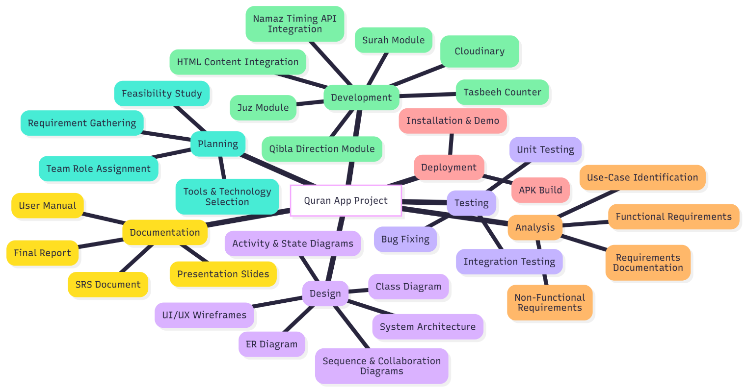
1.1 Work Breakdown Structure (WBS). 1

Work Breakdown Structure (WBS).
Figure 1

Create Milestone table
Milestones are key points in a project that show the completion of important tasks. They help track progress and keep the project on schedule. For the Quran App project, the milestone table shows main activities with their start and end times to ensure timely delivery.

Milestone ID | Activity | Description | Completion Date
M1 | Requirement Gathering Completed | Initial functional and non-functional requirements documented | Week 1
M2 | System Design Finalized | UI/UX design, architecture, diagrams approved | Week 2
M3 | Surah & Juz Module Developed | HTML integration + search + display feature completed | Week 3
M4 | Audio Streaming Integrated | Cloudinary audio links added and tested | Week 3
M5 | Qibla & Namaz Module Completed | GPS-based Qibla + API-based Namaz timings implemented | Week 4&5
M6 | Tasbeeh Counter Implemented | Counter + reset functionality tested | Week 5
M7 | Full App Testing Completed | Unit + integration testing + bug removal | Week 6
M8 | APK Build Ready | Final build generated and packaged | Week 6
M9 | Complete Documentation Submitted | SRS, Final Report, User Manual finished | Week 7
M10 | Project Final Delivery | App deployed /submitted to instructor | Week 7
Table 1

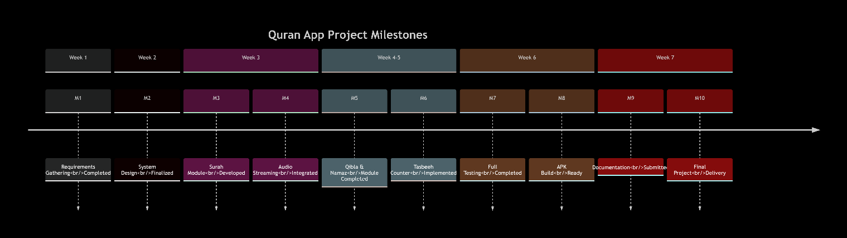
Milestone Chart
Figure 2

Figure 3

Develop an Activity Graph.
The Activity Graph for the Quran App Project shows dependencies between all project tasks. It helps to plan the workflow estimate completion time and identify critical tasks. It represents Planning Design Development Testing Deployment and Documentation phases clearly for the team.
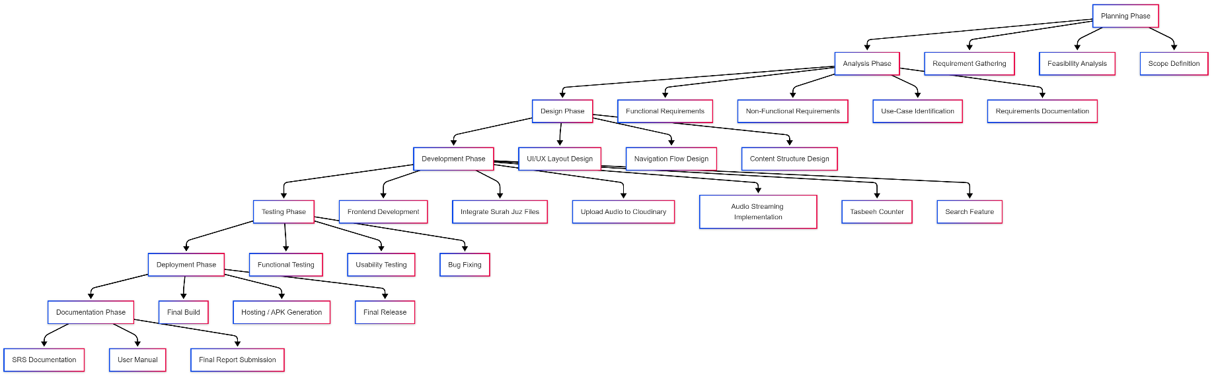
Activity Chart
Figure 3

Find the Critical Path.
The Critical Path is the sequence of project activities that determines the shortest time possible to complete the project. Any delay in these activities directly delays the entire project.

Activity List and Durations
Based on your Milestone Table (M1 to M10), we will define the main activities, their dependencies, and durations in weeks.
Activity (Node) | Description | Duration (Weeks) | Predecessor(s)
A (M1) | Requirement Gathering | 1 | -
B (M2) | System Design Finalized | 1 | A
C (M3) | Surah & Juz Module Dev | 1 | B
D (M4) | Audio Streaming Integrated | 0 (Part of C) | C
E (M5) | Qibla & Namaz Module Dev | 2 (Week 4 & 5) | B
F (M6) | Tasbeeh Counter Implemented | 0 (Part of E) | E
G (M7) | Full App Testing | 1 | C, E
H (M8) | APK Build Ready | 0 (Part of G) | G
I (M9) | Complete Documentation | 1 | G
J (M10) | Project Final Delivery | 0 (Part of I, H) | I, H
Table 2

Note: Activities M4, M6, M8, and M10 are treated as milestones with $\text{Duration}=0$ or are integrated into their preceding development/testing activities (C, E, G, I).

Forward Pass Calculation
The Forward Pass determines the Earliest Start (ES) and Earliest Finish (EF) time for each activity.
- ES=EF of the preceding activity (if multiple predecessors, use the highest EF).
- ES=EF + Direction

Activity | Duration | Predecessor(s) | ES (Week) | EF (ES + Dur) (Week)
A | 1 | - | 0 | 1
B | 1 | A | 1 | 2
C | 1 | B | 2 | 3
D | 0 | C | 3 | 3
E | 2 | B | 2 | 4
F | 0 | E | 4 | 4
G | 1 | C(3), E(4) | 4 | 5
H | 0 | G | 5 | 5
I | 1 | G | 5 | 6
J | 0 | H(5), I(6) | 6 | 6
Table 3

Project Minimum Completion Time: 6 Weeks

Backward Pass Calculation
The Backward Pass determines the Latest Finish (LF) and Latest Start (LS) time for each activity. We start from the project completion time (6 weeks).
- LF=LS of the succeeding activity (if multiple successors, use the lowest LS).
- LF=LS – Direction

Activity | Duration | Successor(s) | LF (Week) | LS (LF - Dur) (Week)
J | 0 | - | 6 | 6
I | 1 | J(6) | 6 | 5
H | 0 | J(6) | 6 | 6
G | 1 | H(6), I(5) | 5 | 4
F | 0 | E | 4 | 4
E | 2 | G(4) | 4 | 2
D | 0 | C | 3 | 3
C | 1 | G(4) | 4 | 3
B | 1 | C(3), E(2) | 2 | 1
A | 1 | B(1) | 1 | 0
Table 4

Calculate Slack and Determine Critical Path

Slack (Float) is the amount of time an activity can be delayed without delaying the project. It is calculated as:
- Slack = LF-EF or Slack= LS-ES
- Activities with Slack=0 are on the Critical Path.

Activity | ES | EF | LS | LF | Slack | Critical Path?
A | 0 | 1 | 0 | 1 | 0 | Yes
B | 1 | 2 | 1 | 2 | 0 | Yes
C | 2 | 3 | 3 | 4 | 1 | No
D | 3 | 3 | 3 | 3 | 0 | Yes
E | 2 | 4 | 2 | 4 | 0 | Yes
F | 4 | 4 | 4 | 4 | 0 | Yes
G | 4 | 5 | 4 | 5 | 0 | Yes
H | 5 | 5 | 6 | 6 | 1 | No
I | 5 | 6 | 5 | 6 | 0 | Yes
J | 6 | 6 | 6 | 6 | 0 | Yes
Table 5

Conclusion
The Critical Path for the Quran App Project is:
A →B →E →G →I →J
(Requirements → Design → Qibla/Namaz Dev → Testing → Documentation → Final Delivery)
The minimum duration for the project is 6 weeks.
- Key Insight: This analysis shows that the Qibla & Namaz Module Development (E), with its 2-week duration, determines the earliest start of the Full App Testing (G), making the path through E the critical one. The Surah & Juz Module Development (C) has one week of slack, meaning it can be delayed by a week without impacting the overall project schedule

Create a Gantt chart.
For the Quran App project, the Gantt chart illustrates the timeline for each phase, including planning, design, development, testing, and deployment. It helps track progress, manage dependencies, and ensure timely completion of the project.

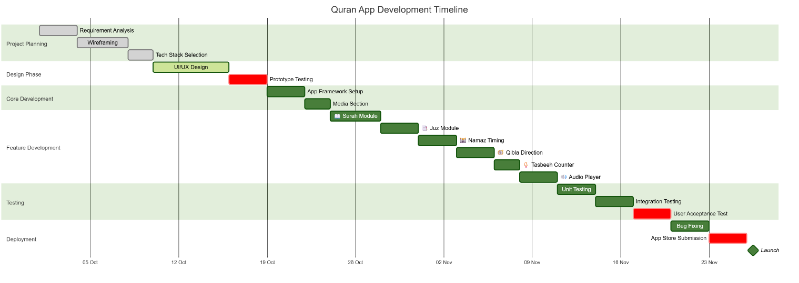
Figure 4

~~~~~~~~~~ Phase II ~~~~~~~~~~

Functional Requirements
The Quran App should behave in response to user interactions. These describe the app’s features such as viewing Surahs, Juz, Namaz Timings, Qibla Direction, and using a digital Tasbee counter. Each function is represented as a use-case to show user–system interactions.

Use Case Diagram
The Use Case Diagram below shows the interaction between the User (actor) and different modules of the Quran App.
The user can:
- Launch and navigate the app
- View Surahs and Juz
- Check Namaz timings
- View Qibla direction
- Use the Tasbee counter

Actors
- User – The primary actor who interacts with the app.

System
- Quran App

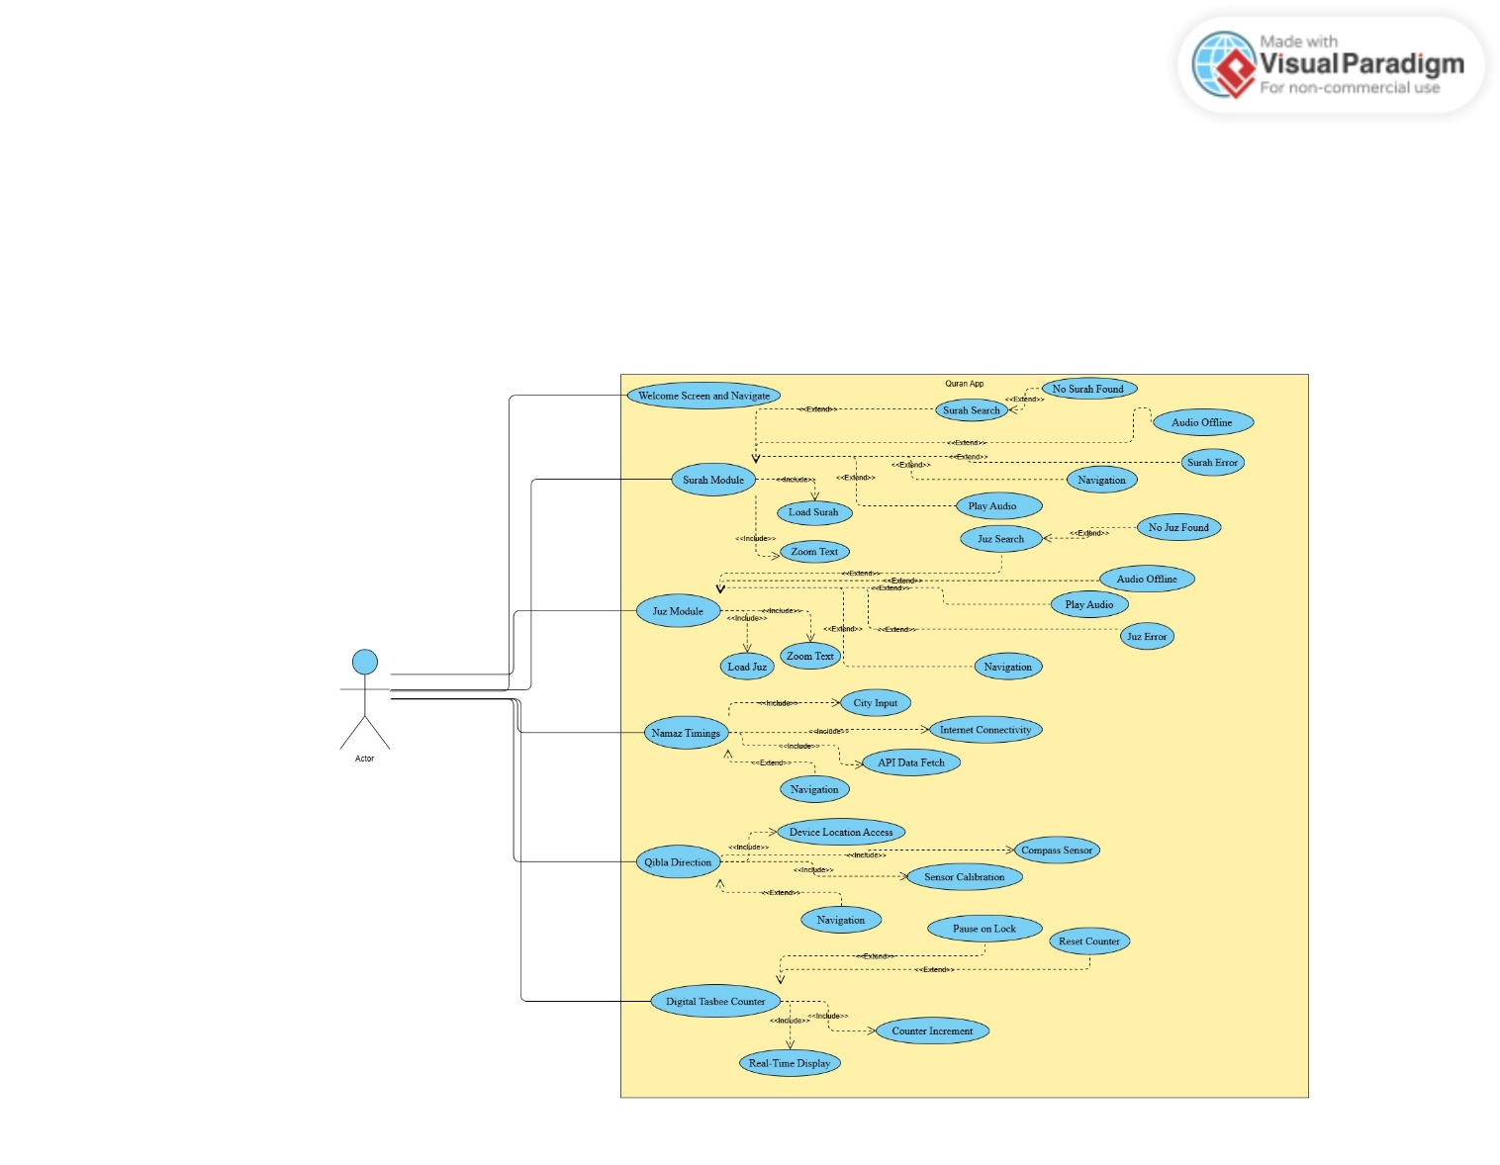
Figure 5

4.1.1 View Welcome Screen and Navigate
Identifier |  | UC-1
Purpose |  | To display the welcome interface and provide access to the main features of the application through navigation.
Priority |  | High
Pre-conditions |  | The application has just been launched by the User.
Post-conditions |  | The User has reached the Main Menu.
Typical Course of Action
S# | Actor Action |  | System Response
1 | Open the app |  | Display welcome text, image, and Get Started button
2 | Click on Get Started button |  | Redirect to the Main Screen with 4 main buttons (Surah, Juz, Direction, Namaz Timing)  and Tasbee Counter at the bottom
3 | Observe Main Screen
  Main Screen is fully loaded and ready for user interaction
Alternate Course of Action
S# | Actor Action |  | System Response
1 |  |  | Return to device home screen; app session ends
  User closes the app before clicking Get Started
Table 6

4.1.2 Surah Module
Identifier |  | UC-2
Purpose |  | To allow the user to explore and interact with Surahs, including searching, reading with Urdu translation, and listening to recitations (if online).
Priority |  | High
Pre-conditions
  User is on the Main Screen.
Post-conditions
  User can read the Surah, play audio if internet is available, and zoom text.
Typical Course of Action
S# | Actor Action |  | System Response
1
  Click on Surah button
  Display Surah Screen with search bar, search button, clear button, and scrollable list of Surahs
2
  Enter keyword or Surah name in search bar and tap Search
  Display matching Surah(s) in the list
3
  Tap on a Surah from list
  Open selected Surah, show Arabic text + Urdu translation
4 |  |  | Play recitation of the Surah
  Tap audio/play button (if internet available)
5
  Scroll through the Surah
  Show additional Ayahs in order
6
  Use zoom in/out
  Adjust text size accordingly
7
  Tap back arrow
  Navigate back to Main Screen
Alternate Course of Action
S# | Actor Action |  | System Response
1
  Search returns no matching Surah
  Display message No Surah found
2 |  |  | Display message Audio unavailable offline; disable play button
  Internet unavailable when audio play is tapped
3 | Surah fails to load
  Display error Unable to load Surah. Try again.
4 | User clears search input using clear button |  | Reset Surah list to full list
Table 7

Juz Module
Identifier |  | UC-3
Purpose |  | To allow the user to explore and interact with Juz sections of the Quran, including searching, reading with Urdu translation, and listening to audio recitations (if connected to the internet).
Priority |  | High
Pre-conditions
  User is on the Main Screen.
Post-conditions
  User can read a selected Juz, view its Urdu translation, play recitation audio (if online), and zoom text for readability.
Typical Course of Action
S# | Actor Action |  | System Response
1 |  |  | Display Juz Screen with search bar, search button, clear button,  and scrollable list of 30 Juz sections
  Click on Juz button
2 | Enter Juz number or keyword in search bar and tap Search |  | Display matching Juz result(s)
3
  Tap on a Juz from the list
  Open selected Juz, show Arabic text and Urdu translation
4 |  |  | Play recitation of the selected Juz
  Tap audio/play button (if internet available)
5 | Scroll through the Juz
  Display Ayahs sequentially within the Juz
6
  Use zoom in/out
  Adjust text size accordingly
7
  Tap back arrow
  Navigate back to Main Screen
Alternate Course of Action
S# | Actor Action |  | System Response
1
  Search returns no matching Juz
  Display message No Juz found
2 |  |  | Display message Audio unavailable offline; disable play button
  Internet unavailable when audio play is tapped
3 | Juz fails to load
  Display error Unable to load Surah. Try again.
4 | User clears search input using clear button
  Reset Juz list to full 30 Juz list
Table 8

4.1.4 Namaz Timing Module
Identifier |  | UC-4
Purpose |  | To enable the user to view accurate Namaz (prayer) timings based on their entered city name.
Priority |  | High
Pre-conditions
  - The user is on the Main Screen.
  - Internet connection is available to fetch real-time timing data.
Post-conditions
  The system displays the 5 daily Namaz timings for the entered city.
Typical Course of Action
S# | Actor Action |  | System Response
1
  Click on Namaz Timing button
  Display Namaz Timing Screen with heading, city input box, and “Get Timing” button
2 | Enter a valid city name in the text box |  | System accepts the input
3
  Tap on Get Timing button
  Open selected Juz, show Arabic text and Urdu translation
4
  Tap audio/play button (if internet available)
  - System fetches prayer timing data for that city
  - Display Fajr, Dhuhr, Asr, Maghrib, and Isha timings clearly on the screen
5
  Tap back arrow
  Navigate back to Main Screen
Alternate Course of Action
S# | Actor Action |  | System Response
1
  User enters an invalid or blank city name
  Display message Please enter a valid city name.
2 |  |  | Display message Unable to fetch timings. Check your connection.
  Internet connection not available
3
  API or data fetch fails
  none
Table 9

Direction / Qibla Module
Identifier |  | UC-5
Purpose |  | To help the user find the accurate Qibla direction in real-time using the device’s compass or location sensors.
Priority |  | High
Pre-conditions |  | - The user is on the Main Screen.  - Device location and compass permissions are granted.
Post-conditions |  | The user can view the Qibla direction accurately based on current location.
Typical Course of Action
S# | Actor Action |  | System Response
1 | Click on Direction button |  | Display Qibla Direction Screen with compass view
2 |  |  | System activates sensors and fetch’s location data
  Allow access to location and device sensors (if prompted)
3 |  |  | System aligns compass needle toward Qibla direction
  Wait for compass to calibrate
4
  Observe Qibla direction on screen
  System shows live direction marker with label “Qibla”
5
  Tap back arrow
  Navigate back to Main Screen
Alternate Course of Action
S# | Actor Action |  | System Response
1
  User denies location/sensor access
  none
2 | Device lacks compass sensor
  none
3
  GPS signal not found
  none
Table 10

Tasbee / Counter Module
Identifier |  | UC-6
Purpose |  | To allow the user to digitally count Tasbee (Zikr) recitations with options to start, increase the count, and reset to zero.
Priority |  | Medium
Pre-conditions |  | - The user is on the Main Screen.  - The Tasbee section is visible at the bottom of the screen.
Post-conditions |  | The Tasbee count is displayed and can be reset by the user.
Typical Course of Action

S# | Actor Action |  | System Response
1
  Scroll to the bottom of the Main Screen
  Display Tasbee Counter section with Start, Reset, and Count Display
2
  Tap on Start button
  Increase the counter by 1 for each tap
3 |  |  | System shows updated count value in real time
  Observe current count
4
  Tap on Reset button
  Counter value resets to 0
5 |  |  | System continues increasing the count accordingly
  Continue tapping Start
Alternate Course of Action
S# | Actor Action |  | System Response
1 |  |  | Counter resets automatically to 0 (session restart)
  App crashes or reloads
  User denies location/sensor access
2 | Device screen locks |  | Tasbee counter pauses until the user reopens the app
3 | User taps rapidly multiple times |  | None
Table 11

Requirements Analysis and Modeling
This section presents a detailed analysis of the system requirements using structured models such as the state diagram, event table, and decision table. These models help visualize system behavior, user interactions, and decision-driven outcomes to ensure a clear understanding of the functional flow.

State diagram

The state diagram illustrates the complete lifecycle of the application, showing how the system transitions between different states such as launch, navigation, content viewing, audio playback, and exit based on user actions.

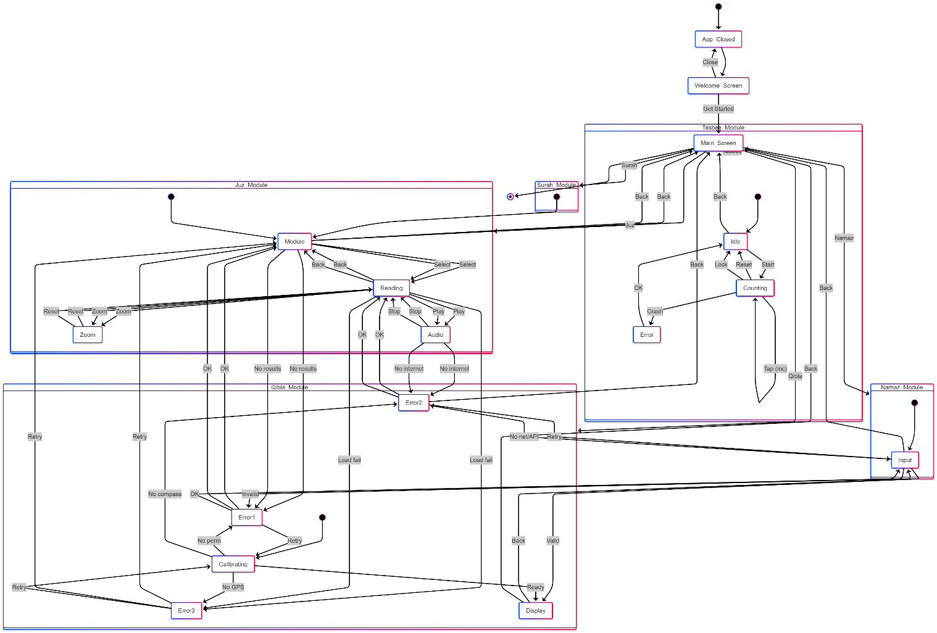
Figure 6

Event Table

The event table summarizes all important user-triggered and system-triggered events, describing how the application responds to each interaction during runtime.
Event | Trigger | Source | System Response
App Opens | User launches app | User | Displays Welcome Screen
Navigate to Main Menu | Auto or user action | System | Shows Main Menu
Open Surah | User selects Surah | User | Displays Surah with translation
Open Juz | User selects Juz | User | Shows Juz with verses
Search | User enters text | User | Returns matching Surahs/Juz
Play Audio | User taps play | User | Streams audio (if online)
Increase Tasbeeh | User taps count | User | Increments counter
Reset Tasbeeh | User taps reset | User | Counter resets to zero
Exit App | User closes app | User | Application stops
Table 12

Decision Table

This table documents conditions where the system provides different outputs based on user actions.

Decision: Surah Audio Playback

Condition | True | False
Internet Available? | Allow audio streaming | Nothing to play audio
Table 13

Decision: Search Result

Condition | Output if TRUE | Output if FALSE
Query matches Surah/Juz | Show result list | Show "No results found"
Table 14

Decision: Tasbeeh Reset

Condition | Output if TRUE | Output if FALSE
User taps Reset | Counter = 0 | Keep current value
Table 15

Nonfunctional Requirements*
Nonfunctional requirements specify how the system performs and behaves, rather than the specific functions. All requirements below are testable and measurable.

Performance Requirements
Performance requirements specify how quickly and efficiently the Quran App should respond under various conditions. Each requirement is measurable and testable.
- App Launch Time:
  - The app shall display the Welcome Screen within 1 second of launch.
  - Rationale: Ensures a smooth first impression and reduces user wait time.
- Surah/Juz Search:
  - Searching for a Surah or Juz shall return results within 2 seconds under normal network conditions.
  - Rationale: Fast search response allows efficient navigation through the Quran content.
- Audio Playback:
  - Recitation audio shall begin within 3–4 seconds when the device is online.
  - Rationale: Minimizes delay in listening to Surah/Juz, enhancing user experience.
- Qibla Direction:
  - The compass needle shall update in real-time and 5 second delay when the device orientation changes.
  - Rationale: Provides accurate and instant Qibla direction for prayer purposes.
- Namaz Timing Retrieval:
  - Daily prayer timings shall load within 5 seconds after entering a valid city name with a stable internet connection.
  - Rationale: Quick retrieval ensures users can access accurate prayer times efficiently.
- Tasbee Counter Responsiveness:
  - Each tap on the Tasbee “Start” button shall immediately increment the count without noticeable delay.
  - Rationale: Ensures reliable counting during Zikr sessions, preventing loss of user progress.
Note: Performance shall remain acceptable under normal device operating conditions and typical network speeds. All features shall degrade gracefully if network or device constraints occur.

Safety Requirements
The safety requirements ensure that the app does not cause harm, data loss, or unsafe behavior for the user or the device.
Data Safety:
- The app shall not modify or delete any system files or other apps’ data.
- User inputs, such as city names or search queries, shall be kept only temporarily and not stored permanently unless explicitly allowed.
Offline Functionality:
- Surah and Juz reading features shall work safely without internet, preventing errors or crashes.
- Any attempt to play audio offline shall display a clear message instead of causing the app to fail.
- Device Safety:
  - The app shall not overuse device sensors (e.g., GPS, compass) in a way that drains battery excessively.
  - Tasbee counter and other interactive elements shall function normally even if the device is locked or screen orientation changes.
- Error Handling:
  - The app shall provide clear and safe error messages when APIs fail or network is unavailable.
  - Any failure in fetching Namaz timings, Qibla direction, or audio shall not crash the app.
- User Permissions:
  - Location and sensor access shall be requested only when necessary (for Qibla or Namaz Timing modules).
  - Denying permissions shall not prevent the user from using other features safely.

Security Requirements
The security requirements ensure that the app protects user data, prevents unauthorized access, and maintains the integrity of content.
- User Privacy:
  - The app shall not collect or store any personal user information (such as city names, search history, or app activity) permanently unless explicitly authorized.
  - All inputs, such as city names for Namaz timings, shall be used temporarily only for processing and cleared after use.
- Secure Communication:
  - All data fetched from online APIs, including Namaz timings, audio recitations, and Qibla direction, shall use HTTPS or other secure protocols to prevent data interception.
  - Any sensitive content shall be retrieved only from trusted and verified sources.
- Permissions Management:
  - Location and device sensor access shall be requested only when required for Qibla direction or Namaz Timing modules.
  - Denying permissions shall not block access to other app features, ensuring safe functionality.
- Content Integrity:
  - Audio recitations and Surah/Juz text shall be verified for authenticity to prevent corrupted or fake content.
  - The app shall prevent unauthorized modification of Quranic content or database files.
- Authentication and Access Control (if needed in future updates):
  - If user accounts or settings are introduced, secure authentication (e.g., password or PIN) shall be implemented.
  - Access to admin or update features shall be restricted to authorized personnel only.

Additional Software Quality Attributes

- Usability:
  - The app shall have a simple, intuitive interface suitable for all age groups.
  - Buttons, menus, and text shall be clearly visible and easy to interact with.
  - Users should be able to access main features (Surah, Juz, Namaz Timing, Qibla, Tasbee) within 3 taps.
- Reliability:
  - Core features (Surah/Juz reading) shall work offline without errors.
  - Online features (audio playback, Namaz Timing, Qibla) shall function correctly when internet is available.
  - App shall handle errors gracefully without crashing.
- Portability:
  - The app shall run on Android devices 5.0 and above, supporting different screen sizes and orientations.
  - The app shall function on multiple devices without requiring additional configuration.
- Maintainability:
  - Code and app modules shall be structured and modular, allowing easy updates, bug fixes, or addition of new features.
- Testability:
  - Each module (Surah, Juz, Namaz Timing, Qibla, Tasbee Counter) shall be independently testable.
  - Functional and non-functional requirements shall have clear criteria for verification.

- Adaptability / Flexibility:
  - The app shall automatically adjust to different screen resolutions and orientations.
  - The system design allows for future feature additions, such as Dua notifications or bookmarks.
- Performance Robustness:
  - The app shall handle rapid user interactions, such as multiple Tasbee taps or frequent scrolling, without lag or errors.
  - Response time for all key actions shall meet performance requirements under normal operating conditions.
- Interoperability:
  - The app shall integrate with standard online APIs for Namaz timings, Qibla, and audio content.
  - External libraries and resources shall be verified and compatible with the app framework.

Other Requirements
This section covers all additional requirements not addressed in the previous chapters. These include interface requirements, compatibility constraints, internationalization, legal considerations, and reuse potential.
6.1 External Interface Requirements
- The application requires a smartphone device capable of running MIT App Inventor–based applications.
- An active internet connection is required for audio streaming from Cloudinary and for fetching Namaz timings from external APIs.
- The Qibla module relies on GPS and device compass sensors for accurate direction calculation.
6.2 Data Storage Requirements
- The system does not use SQL, Firebase, or TinyDB.
- All content (Surah, Juz, Urdu translation) is stored in local HTML files embedded within the application.
- Audio files are stored externally on Cloudinary, accessed through secure URLs.
6.3 Internationalization Requirements
- The application supports:
  - Arabic text (Quranic text)
  - Urdu translation
- The UI is designed to properly render RTL (Right-to-Left) content.
6.4 Legal and Ethical Requirements
- Quranic text and translations must be handled with accuracy, respect, and no unauthorized alterations.
- Audio recitations are used with proper attribution (if required).
- The app must not display any ads or inappropriate content during Quran reading or listening.
6.5 Reuse and Scalability Requirements
- HTML-based content structure allows easy addition of new Surahs, translations, or extra modules in the future.
- Cloudinary URLs can be updated or replaced without changing the core app logic.
- The modular design supports reuse of components such as audio streaming, search, and text display.
6.6 Performance Requirements
- Audio streaming should load within 2–3 seconds on a stable network.
- HTML content should open instantly as it is stored locally.
- The app should function smoothly on low-end Android devices.

Designing

Complete class diagram
The class diagram represents the structural design of the Quran App, showing all classes with their attributes, methods, and relationships. It highlights interactions between main modules such as Surah, Juz, Namaz Timing, Qibla, and Tasbee Counter, ensuring clear organization and maintainability.

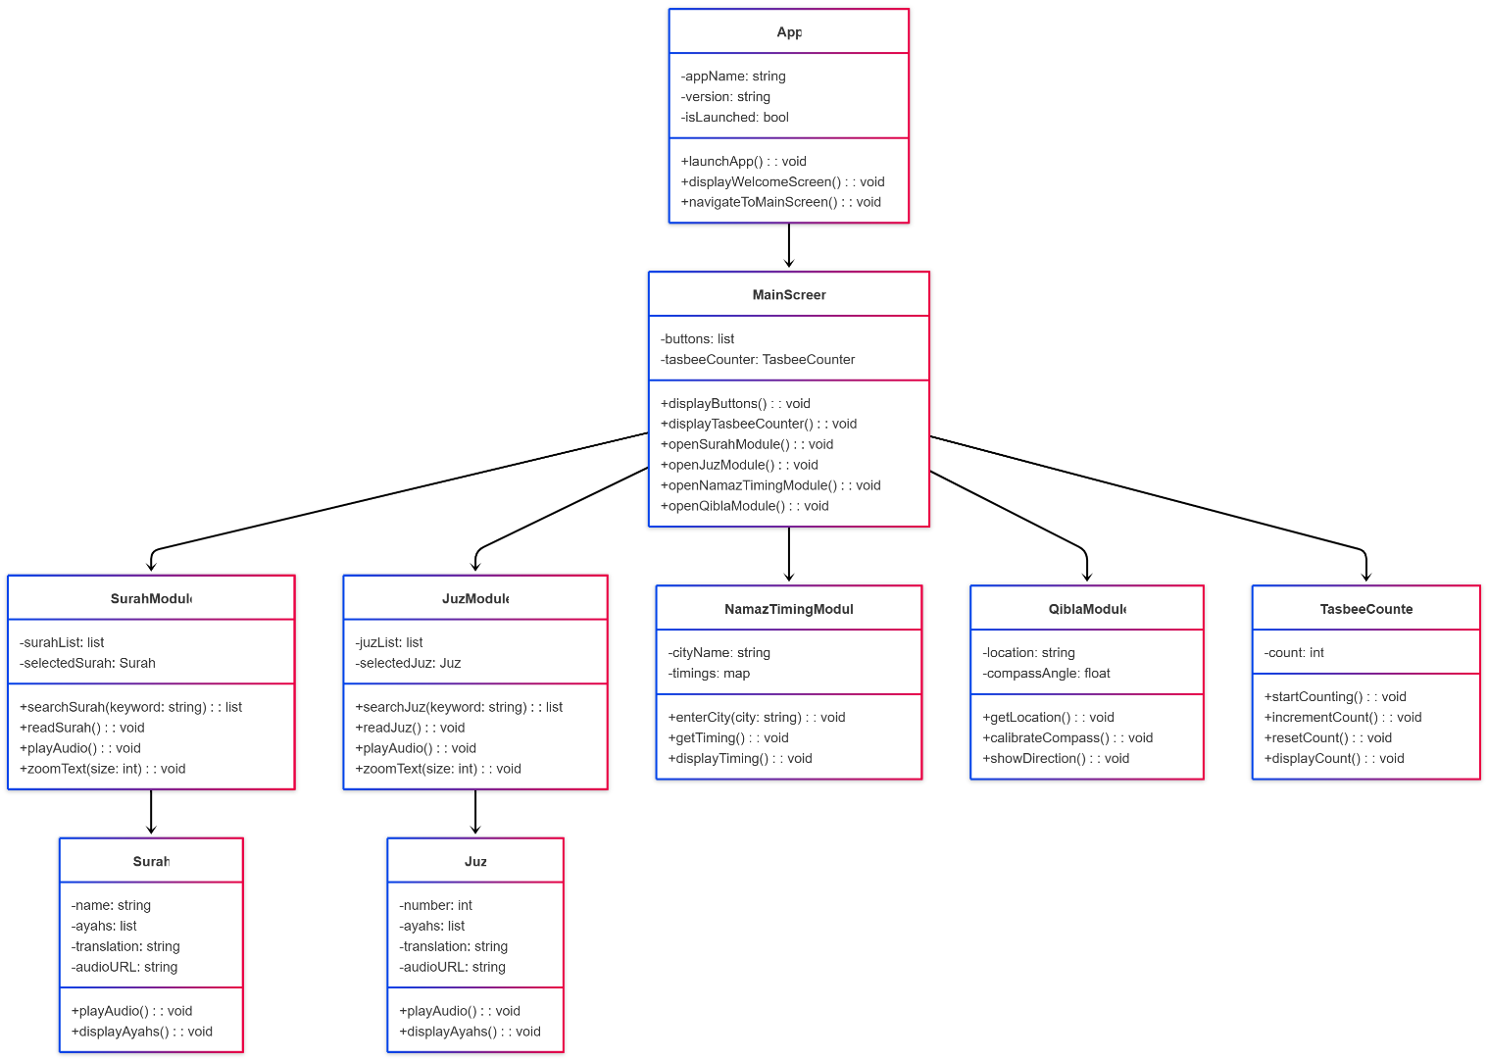
Figure 7

Complete Data Flow Diagram (DFD)
The DFD illustrates the flow of information within the application, from external entities like the user and APIs to internal data stores and modules. Both Context-level and Level 1 DFDs provide a clear view of how data moves across the system for all core functionalities. DFD Level 0
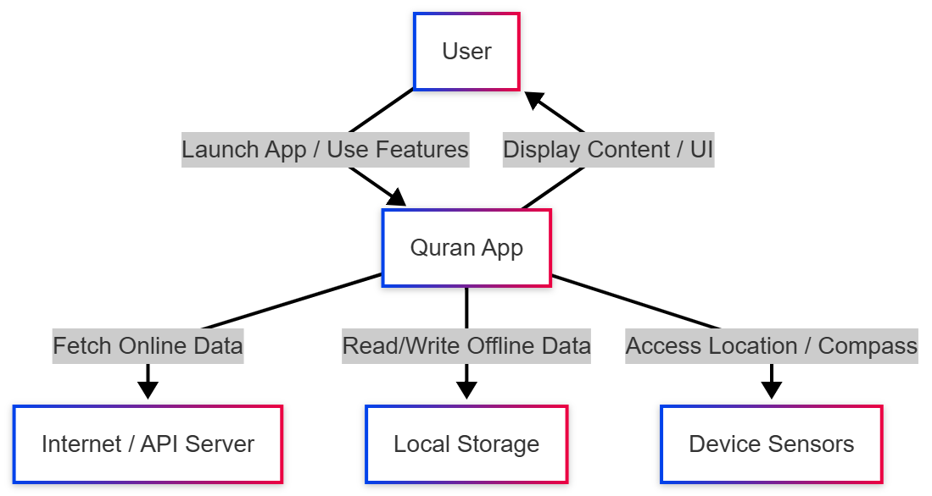
Figure 8
DFD Level 1
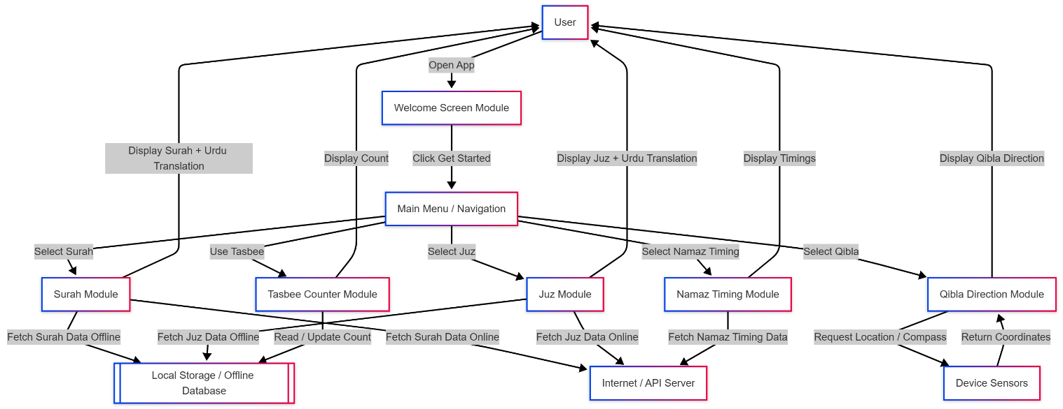
Figure 9

DFD Level 2
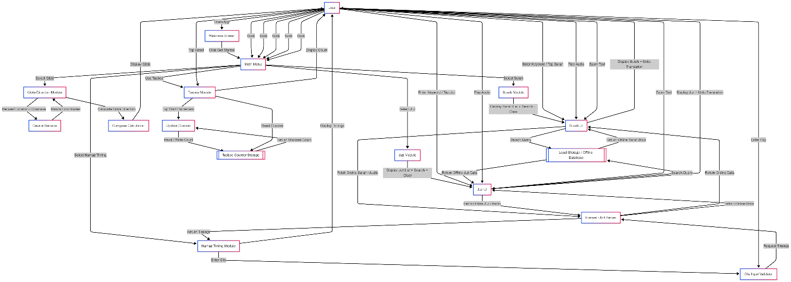
Figure 10

Complete ER Diagram
The ER diagram models the database structure for the Quran App, showing entities, their attributes, and relationships. It ensures data integrity and proper organization for Surahs, Juz, Namaz timings, Qibla directions, and Tasbee counts.

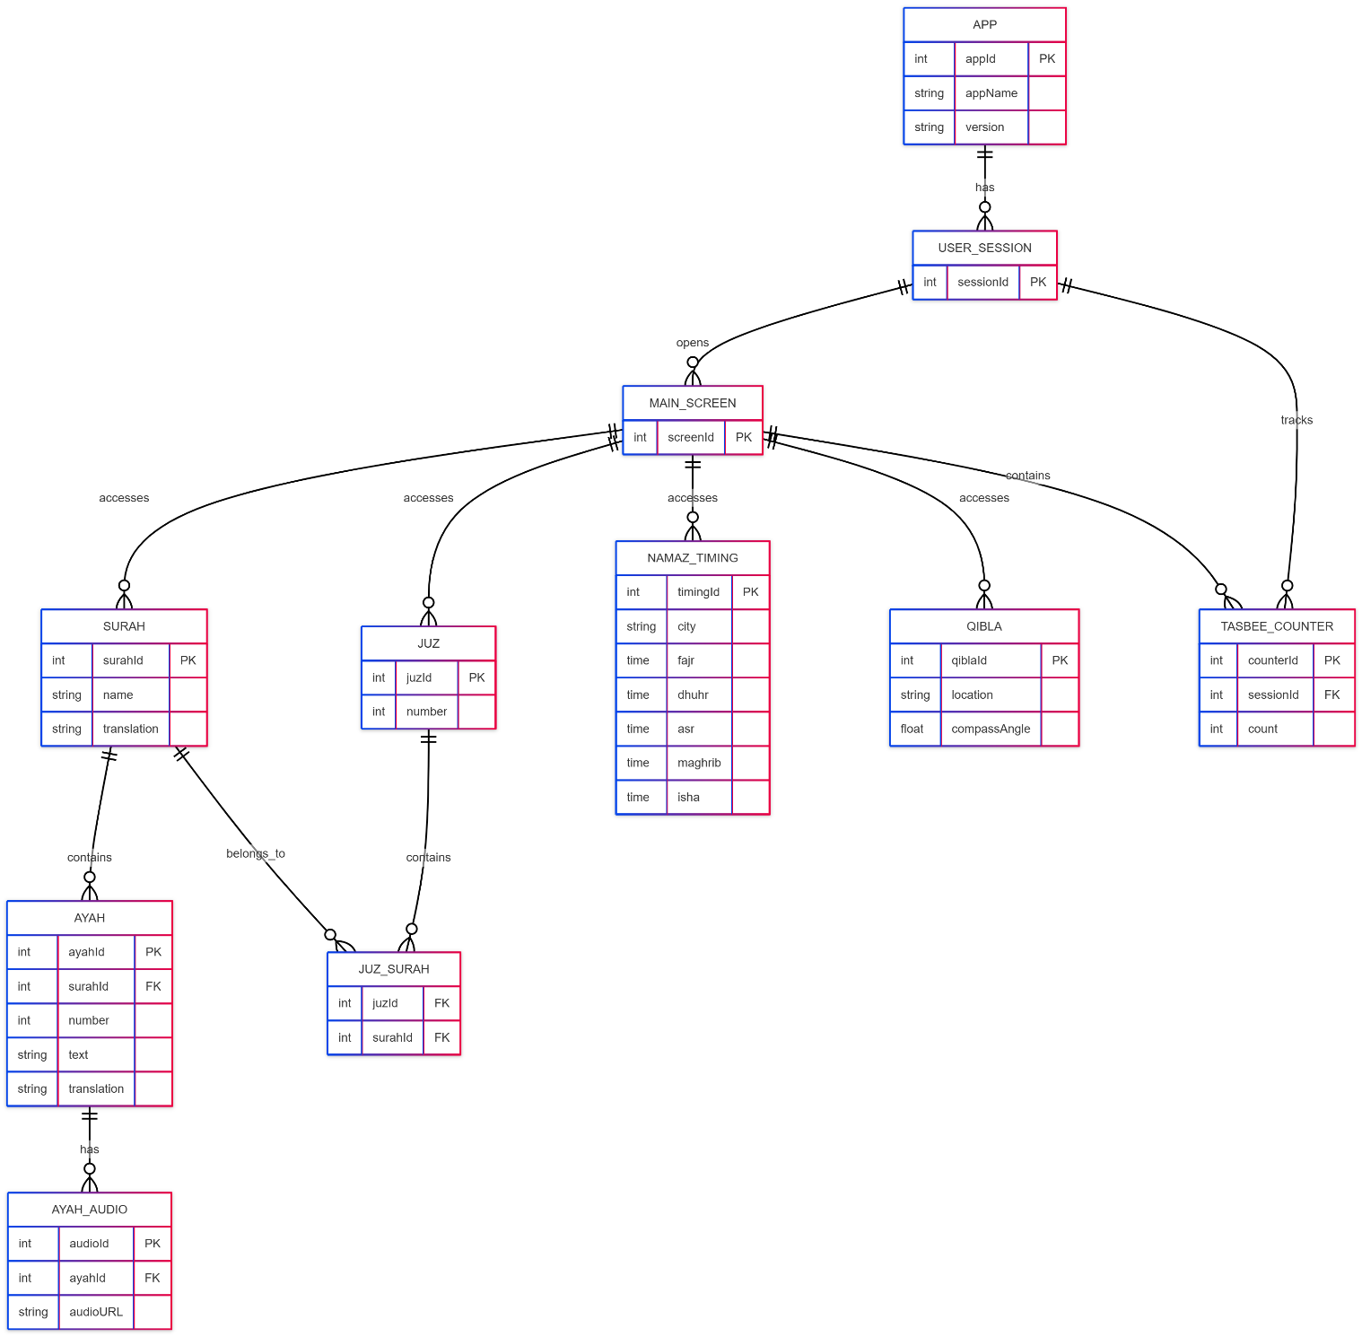
Figure 11

Physical design of your database
The application does not use any traditional database system. All Surah, Juz, and Urdu translation content is stored in local HTML files, which are directly loaded at runtime. Audio recitations are hosted on Cloudinary, and the app accesses them through embedded Cloudinary URLs.
Since all data is handled through static HTML files and cloud-stored audio, no database tables or schema are required.

Information on use of design patterns while designing the modules
While designing the Quran App modules and class diagram, several design patterns were applied to ensure modularity, maintainability, and reusability of the code:
- Singleton Pattern
  - Used for the App class to ensure there is only one instance of the application running at a time.
  - Provides a global point of access for app-wide services like navigation or configuration.
- Facade Pattern
  - Applied to the MainScreen class which serves as a unified interface to access all modules (SurahModule, JuzModule, NamazTimingModule, QiblaModule, TasbeeModule).
  - Simplifies interaction for the user and isolates module complexities.
- Factory Pattern
  - Implemented in SurahModule and JuzModule for creating Surah and Juz objects dynamically based on user input.
  - Makes the module flexible and scalable when adding new content types.
- Observer Pattern
  - Used in the TasbeeCounter class to update the UI automatically whenever the count changes.
  - Ensures real-time feedback to the user without tight coupling between counter logic and UI.
- Command Pattern
  - Applied to TasbeeModule actions like Start, Increment, and Reset.
  - Encapsulates user actions as objects, making it easier to undo/redo or manage sequences of operations.
- Strategy Pattern
  - Used in modules that involve dynamic behavior selection, such as AudioService, NamazTimingModule, and QiblaModule.
  - Allows the app to choose different algorithms at runtime depending on the context (e.g., online/offline audio streaming).
- Adapter Pattern
  - Applied in AudioService to connect external audio APIs or recitation services with the internal application architecture.
  - Provides a consistent interface while hiding the underlying API complexities.
These design patterns were highlighted and applied in the class diagram wherever relevant to promote clean, reusable, and maintainable code.

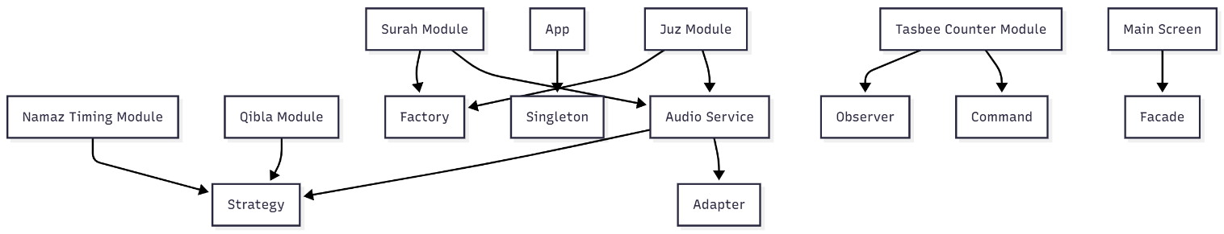
Figure 12

Make a Sequence and a Collaboration diagram of following.
The sequence and collaboration diagrams illustrate dynamic interactions within the Quran App for different user scenarios. They capture how objects and modules such as Surah, Juz, Namaz Timing, Qibla, and Tasbee Counter interact over time to perform tasks like fetching data, displaying content, and handling user input.

Scenario 1
Sequence Diagram: Illustrates the initial launch of the app and usage of the Surah module. It covers user interactions from opening the app, navigating the main menu, searching, and playing audio, emphasizing content retrieval from local or online databases and validation of user input.
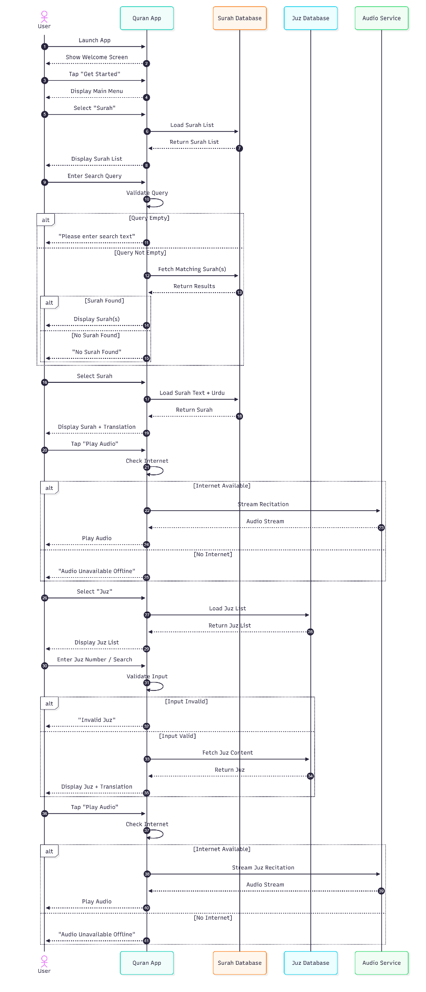
Figure 13
Collaboration Diagram: Demonstrates user interaction with the Surah module, showing the flow of fetching data from local cache or API, displaying content, and streaming audio. Emphasizes collaboration between user, main menu, module, database, and API components.
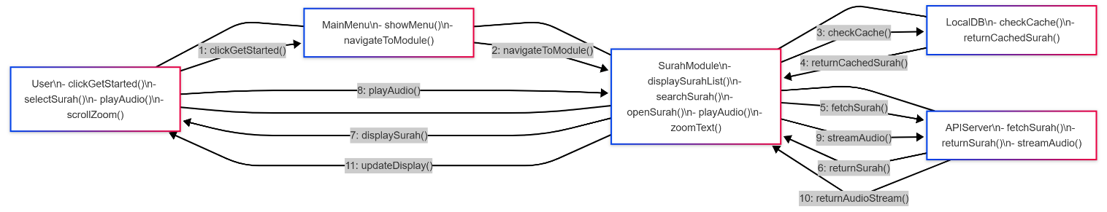
Figure 14

Scenario 2
Sequence Diagram: Focuses on the Juz, Namaz Timing, Qibla direction, and Tasbeeh Counter modules, along with app exit operations. Highlights interaction with external services (API/GPS), user input validation, and local counter updates, demonstrating smooth integration of real-time features and device sensors.
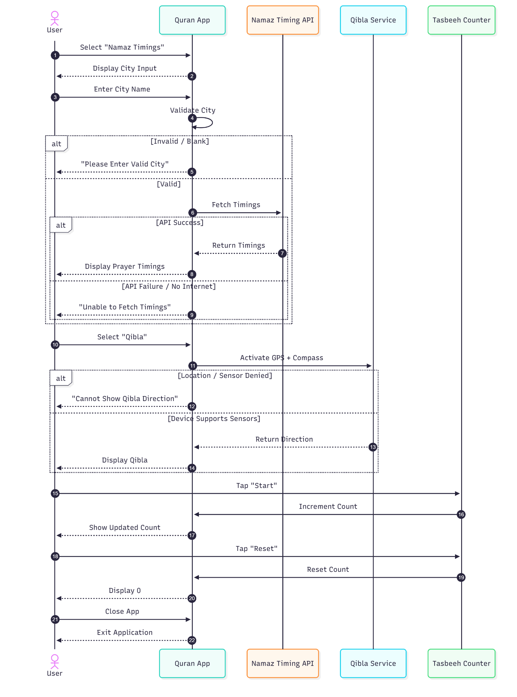
Figure 15
Collaboration Diagram: Illustrates user interactions with the Juz module, including fetching content from local DB or API and updating the display after audio playback. Shows modular interaction between user, main menu, Juz module, database, and API services.
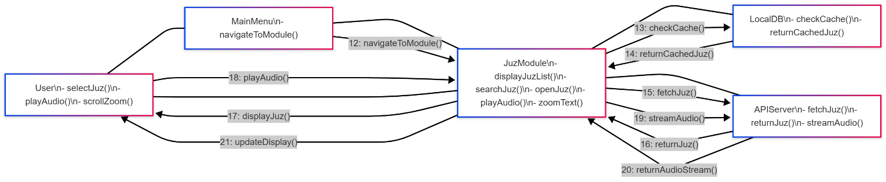
Figure 16

Estimation
This section provides an approximate estimation of the project cost, benefits, effort, and time required for the development of the Quran App. It includes Cost-Benefit Analysis, Return on Investment, Function Point (FP) estimation, and COCOMO estimation.

Cost-Benefit Estimation
Cost-Benefit Estimation helps in evaluating the financial feasibility of the project. For the Quran App, we make the following assumptions:
- Development time: 36 days (from CPM analysis)
- Team size: 5 students
- Working hours: 4 hours/day per student
- Student cost: 150 PKR/hour
- Tools & APIs: Free tier (MIT App Inventor, Cloudinary, Prayer timing API)
- Benefits: Estimated as deployable app, educational and social value

8.1.1 Cost Estimation
Cost Component | Calculation | Amount(pk)
Development Cost | 5 × 36 × 4 × 150 | 108,000
Tools & Software | MIT App Inventor + Cloudinary (Free) | 0
API Costs | Prayer timing API (Free) | 0
Content Preparation | Quran text formatting + Urdu translation | 20,000
Testing Devices | Access to multiple Android devices | 10,000
Documentation | Printing, binding, submission | 5,000
Miscellaneous | Internet, electricity, transportation | 7,000
Total Cost | Sum of all above | 150,000
Table 16

8.1.2 Benefit Estimation
Benefit Component | Estimation Basis | Value(pk)
Educational Value | Skill development for 5 students | 200,000
Deployable Product | Market value of similar basic apps | 100,00
Social Impact | Value to potential users (free app) | 150,000
Academic Credit | Value of completed degree requirement | 250,000
Future Opportunities | Portfolio value for job applications | 100,000
Total Benefits (1st Year) | Sum of all above | 800,000
Table 17

Return of Investment (ROI) {1st year}
Formula:

ROI = Benefits / Cost

Calculation:

ROI = 80,000 / 150,00 ≈ 5.33

Interpretation:
For every 1 PKR invested, the project generates 5.33 PKR in value.

%gain on ROI {1st year}

Formula:

% Gain= (Benefits - Cost / Cost) × 100

Calculation:

% Gain= (800,000 – 150,000 / 150,000) × 100 ≈433%

Interpretation:
The project is estimated to generate a 433% gain over the initial investment.

Payback Period in years
Formula:

Payback Period= (Cost / Benefits) × 100

Calculation:

% Gain= (150,000 / 800,000) ≈ 0.1875 years ≈ 2.25 months

Interpretation:
The project is estimated to generate a 433% gain over the initial investment

FP based Estimation
Using approximate function points for the app:

Module | FP | Weighting | Weighted FP
Surah Module | 5 | 4 | 20
Juz Module | 5 | 4 | 20
Namaz Timing API | 3 | 5 | 15
Qibla Direction Module | 2 | 5 | 10
Tasbeeh Counter | 1 | 3 | 3
Audio Streaming | 2 | 5 | 10
Search & Integration | 3 | 4 | 12
Total FP |  |  | 90
Table 18

Estimated Effort:

Formula for Effort: Effort (Person−Hours) =FP × Hour Weight

$$Effort(Person-Hours)=FP×8≈90×8=720\text{ hours}$$
Estimated Duration:

Formula for Duration: Duration (Days)= Effort / Numbers of students × hours / days

Duration (Days)= 720 / 5 students × 4hr / days = 36 days

COCOMO Estimation
COCOMO provides approximate effort and time based on software size (KDSI/LOC) and project type:
Effort (Person−Months) =2.4×(KDSI)1.05
Duration (Months)=2.5×(Effort)0.38
Assumptions:
- Project size ≈ 3 KDSI (Thousand Delivered Source Instructions)
Calculation:
$$Effort=2.4×(3)^{1.05}≈7.6\text{ Person-Months} \\ Duration=2.5×(Effort)^{0.38}≈4.5\text{ Months (5 students part-time)}$$
Interpretation:
The estimation roughly aligns with the FP-based duration (36 days full-time for 5 students), validating project planning.

9. References
This section lists all the books, websites, tools, and online resources used while preparing this SRS. All references were managed using the Zotero Reference Manager to ensure accuracy and consistency.
Books & Academic Sources
- Pressman, R. S., & Maxim, B. R. (2015). Software Engineering: A Practitioner’s Approach (8th ed.). McGraw-Hill Education.
- Sommerville, I. (2016). Software Engineering (10th ed.). Pearson Education.
- Jalote, P. (2005). An Integrated Approach to Software Engineering (3rd ed.). Springer.
Websites & Online Tools
- MIT App Inventor. (n.d.). Official Documentation. Retrieved from:
https://appinventor.mit.edu
- Cloudinary. (n.d.). Media Upload API Documentation. Retrieved from:
https://cloudinary.com/documentation
- Aladhan API. (n.d.). Prayer Time REST API. Retrieved from:
https://aladhan.com/prayer-times-api
- GitHub. (n.d.). Open-source repositories and code samples. Retrieved from:
https://github.com
AI Tools & Assistants Used for Learning / Design Suggestions
- OpenAI. (2024). ChatGPT – Generative AI Assistant. Retrieved from:
https://chat.openai.com
- GitHub. (2024). GitHub Copilot – AI Programming Assistant. Retrieved from:
https://github.com/features/copilot

- Google DeepMind. (2024). Gemini Pro – AI Model Documentation. Retrieved from:
https://deepmind.google
- Google Search. (n.d.). UI/UX and Mobile App Design Suggestions. Retrieved from:
https://www.google.com
Learning & Multimedia Resources
- YouTube. (n.d.). Mobile App Development & UI/UX Tutorials. Retrieved from:
https://www.youtube.com
- Lecture Notes & Classroom Sessions by Mr. Sawail Khan, Faculty of Computer Science & IT, The Superior University (2024). Course Lectures on SRS, UML, and Project Documentation.
Diagramming and Modeling Tools
- Mermaid. (n.d.). Mermaid Documentation: Diagramming and Charting Tool. Retrieved from: https://mermaid.js.org
- Visual Paradigm. (n.d.). Visual Paradigm Official Website. Retrieved from: https://www.visual-paradigm.com
Software Estimation Resources
- Boehm, B. W. (1981). Software Engineering Economics (COCOMO Model). Prentice-Hall.
- IFPUG. (2020). Function Point Analysis Guide. Retrieved from:
https://www.ifpug.org

Appendix A: Glossary
This glossary provides definitions of important terms, abbreviations, and technical concepts used throughout the Software Requirements Specification (SRS) of the Quran App. These terms ensure clear understanding and consistent interpretation of the document.
- API – A service that allows the app to receive data from external sources (e.g., prayer timings).
- App – The mobile application developed for Android devices.
- Backend – The server-side processes that handle data, audio streaming, and logic behind the app.
- Cloudinary – An online cloud service used to store and deliver audio files securely.
- FP (Function Point) – A method used to estimate the project size and required development effort.
- GPS – A location-based system used to determine Qibla direction for prayers.
- HTML – Markup language used to format and display Quranic text within the app.
- MIT App Inventor – The platform used to design and build the Quran App visually.
- Namaz Timing API – A free service that provides accurate daily prayer timings.
- Qibla Direction – The direction (toward the Kaaba) Muslims face while praying.
- Quran Module – Part of the app responsible for showing Surah, Juz, translation, and audio.
- SRS – Software Requirements Specification, the main document describing the entire project.
- Tasbeeh Counter – A digital counting module for dhikr and daily tasbeeh repetitions.
- UI/UX – The design and user experience elements that make the app easy to use.
- Testing – The process of checking the app for issues, bugs, and performance problems.

